Integration of ICT in Restaurants Post-COVID

Tadiwanashe Songore

Grade 12a| hORIZON HIGH SCHOOL

COMPUTER APPLICATIoN TECHNOLOGY

Contents

Table of Figures 1

Introduction 2

Task definition 3

Focus Question 4

How have the restaurants been affected by the pandemic? 4

Discussion and Analysis 5

Findings 6

Conclusion 7

Bibliography 8

Appendices 0

Addendums A 1

Addendum B 2

ADDENDUM 2: SOURCE TABLE – 2021 0

Source Table 1

Table of Figures

Figure 1 Empty restaurant 2

Figure 2: customers worried about indoor dinning 4

Figure 3 Woman dining in restaurant 6

Figure 4 PAT folder layout 2

# Introduction

The following document talks about Integration of ICT in Restaurants Post-COVID.

Figure Empty restaurant

After reading through the document and its research the reader will fully understand how ICT has taken over in restaurants all over the world in so many ways that benefit the world and prevents the spread of the corona Virus in the world.

In the past ten years, South African gastronomy has seen a huge increase, which is related to the growth of tourism in South Africa, especially in the coastal areas. In addition, South African wine, South African cuisine and South African chefs are internationally renowned, which has increased the number of wine and food tourists by. According to data from Bank of South Africa, industries and entertainment accounted for 10% of the industries in 2018. The company is in South Africa with 9% service staff and 3% turnover. The catering industry plays an important role in the country’s economy Although many small and medium-sized restaurants closed in the first four years of operation, this is an example of the need for a strategy to provide financial support foreign business 5 Other authors also pointed out hotels The importance of business survival strategy and restore consumer confidence. economic flexibility refers to the additional income provided to local residents to compensate for the existence of tourists and the benefits they bring. can also be defined as the local economic improvement that can bring to India by the development of tourism. In the long term, all the effects that affect different sectors and the local industrial economy are taken into consideration. Organizational [Sustainability](https://www.mdpi.com/journal/sustainability) and sustainability remain a challenge for SMEs because of their limited resources and organizational structure. Economic growth achieved sustainability 2021, 13, 40. [https://dx.doi.org/10.3390/su13010040](https://dx.doi.org/10.3390/su13010040%20) sustainability 2021, 13, 40 2 of 13 for strong Fiscal incentives or a combination of tax cuts and increased spending may have disastrous long-term consequences for the macroeconomic stability of approximately countries. ... Due to restrictions imposed by most countries to control the spread of the pandemic, the recent health crisis caused by COVID19 quickly turned into a financial recession. This sudden crisis particularly affected the tourism industry and thus the gastronomy. It is one of the worst-hit restaurants. restaurants had to be closed or operated under strict restrictions, and only take-out and food delivery services were allowed in South Africa.

# Task definition

We have started to see a problem in this world which is called the coronavirus it is a virus that is caused very emotional and physical pain to so many people I am doing this research an investigation to help my friends see why and how covid has affected people and restaurants.

The purpose and focus of this investigation is to help my friends understand that COVID-19 was not a joke and it played major problems in many people's lives and restaurants my research will cover how it affected restaurants .How restaurants tried to counter it and how restaurants overcome the [COVID-19](https://sacoronavirus.co.za/) pandemic the restaurants look for a lot of alternatives such as  
understanding how they managed to deliver services and food to their customers finding out how they managed to get paid without going to the actual store   
finding out how they managed to order their food without actually seeing the posters inside of the store   
finding out how they controlled the staff inside of the store and helping prevent the spread of COVID-19 through the delivery of food   
finding out how they manage to prevent the spread of COVID-19

The target audience for this research are my friends this will help him see that everyone was affected during and still is affected by the COVID-19 pandemic although things are managing to get better there are still at some sort of disadvantage.

# Focus Question

## How have the restaurants been affected by the pandemic?

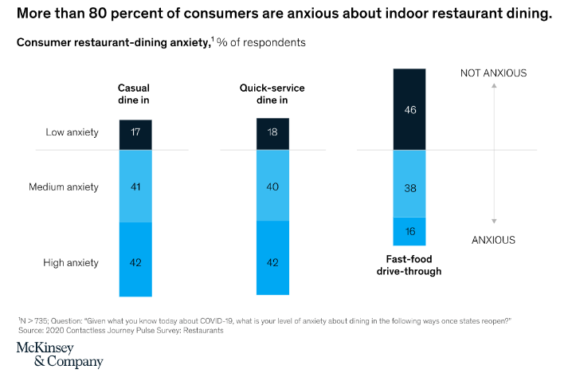 Indoor dining in restaurants might not come to pre-crisis levels for months – or possibly even years. For full-service eating place operators, it suggests that developing a new semipermanent economic model.

Figure : customers worried about indoor dinning

There are opportunities to optimize takeaway and drive-through operations and re-engineer menus and pricing. This would possibly embrace finding the proper balance of special offers and high-margin things appreciate appetizers, sides, desserts and beverages. (knowlage, 2020)

# Discussion and Analysis

Purpose This study aims to look at the employment of Front of House (FOH) and Back of House (BOH) technology applications in numerous sorts of S.A buildings beside their level of IT management and explore the importance of those technology applications to restaurant operations. Design/methodology/approach Survey information were collected from five hundred indiscriminately elite restaurant technology managers who purchase welcome Technology Magazine. The sample cluster showed 67,299 restaurant units. information analysis was organized into 3 elements (descriptive, alpha issue analysis, and freelance samples t-test). Findings For FOH, the top-five purposes of sale (POS) technologies used are POS hardware, touchscreen, POS software, gift card integration Associate in Nursing integrated Mastercard swipe into POS. At the BOH, the top-five POS technologies used are accounting/financial software, enterprise reporting, inventory management software, room printers and company intranet. Originality/value this is often one in all the primary studies to incorporate a range of technologies utilized in buildings. Most existing studies target one technology or low variety of them. However, this study provides an overall perspective on a variety of restaurant technologies from FOH to BOH. It additionally includes mobile POS technologies.

# Findings

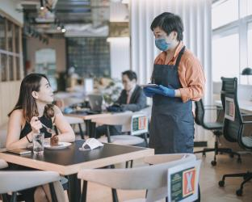The restaurant’s average annual sales are approximately R1 million and operating profit is only 45%. On average, restaurants spend 30% of their income on work. With increasing attention to fair wages and legal wage growth, restaurants can easily outperform this average. They turned to pick-up and delivery, and improved their pick-up and lane skills. employees may be reluctant to return due to the combination of state unemployment benefits and a federal allowance of R600 per week, easy to eat out, use transparent screens or other physical barriers to limit tables, limit the number of people at each table, and increase outdoor seating. Provide health and safety training and shifts, more flexible sick leave policies, frequent days, etc. Thoroughly clean all surfaces, non-contact interactions between customers and service personnel, scanning QR codes, one-time or non-contact use, ordering and payment from mobile devices, service personnel control and use of gloves, etc. people go to restaurants because restaurants are part of people's lives. When sick employees go to work, send them home immediately before they come into contact with anyone and ask them to see a doctor," he said. "If they are sick enough to be tested and tested positive, please contact the local health department Trace contacts to minimize the risk of employees contacting others, including electronic payments, contactless payments, electronic payments and mobile wallets. From external delivery drivers, restaurants may consider implementing a locker system to keep food at the correct temperature before receiving it. It is possible to track, protect and record who picked up the food, thereby recording the time of the food. (knowlage, 2020)

Figure Woman dining in restaurant

# Conclusion

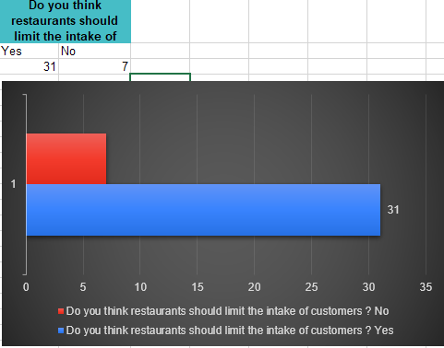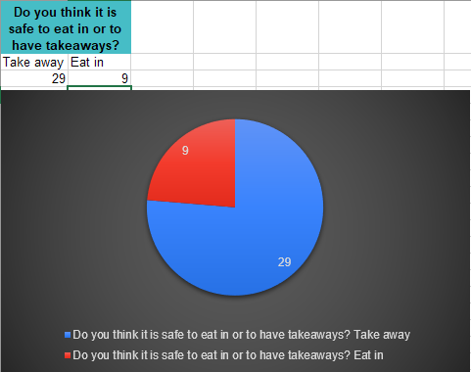From all the data I have collected from my google forms and put on Excel I have come to the understanding that restaurants have completely changed for the better because of covid-19. Some people would go to the restaurants every weekend but now they are not allowed to dine in restaurants any more. People will now be forced to switch to takeaways so the help prevent the spread of Covid during these tough times although most people that completed the survey feel safer with dining in restaurants. Regardless of what they think and feel the ruling of such decisions are made by the president. So, this all results in deliveries and take-aways. Most restaurants will close down because they do not have delivery services.

# Bibliography

knowlage, H. w. (2020, 08 10). *Forbes.com*. Retrieved from https/://www.forbes.com/sites/hbsworkingknowledge/2020/08/10/restaurant-revolution-how-the-industry-is-fighting-to-stay-alive/?sh=159b2b30f1eb

Miele, R. S. (2021, May 5). Restaurant owner. (T. Songore, Interviewer)

now, T. a. (2020, July 14). *Employee testedd positive* . Retrieved from https://restaurant.org/articles/news/your-employee-is-positive-for-covid-19-now-what#:~:text=Importantly%2C%20the%20CDC%20has%20indicated,tests%20positive%20for%20COVID%2D19.&text=%E2%80%9CIf%20the%20sick%20employee%20comes,a%20doctor%2C%E2%80%9D%20he%20s

Appendices

# Addendums A

|  |  |  |  |
| --- | --- | --- | --- |
| Learner name | Tadiwanashe Songore | ID Number | FN880005 |
| Grade | 12 | Year | 2021 |
| Subject | Computer Applications Technology | | |
| Practical Assessment Task (PAT) | | Teacher | Mr. Cyan |
| Did you receive any help/information from anyone to complete this project?  No Yes (provide details below) | | | |
| Help/Information received  from (person): | Nature of the help/information (provide evidence): | | |
|  |  | | |
| I hereby declare that the contents of this assessment task are my own original work  (Except where there is clear acknowledgement and appropriate reference to the work  of others) and that I have not plagiarised, copied from someone else or used work  previously submitted for assessment by anyone. | | | |

# Addendum B



Figure PAT folder layout

ADDENDUM 2: SOURCE TABLE – 2021

# Source Table

|  |  |  |  |  |  |  |  |  |  |
| --- | --- | --- | --- | --- | --- | --- | --- | --- | --- |
| No. | Question | Question Level (1,2,3,4) | Category | Type of  Source | Bibliographical information | | Quality of Information found | | Summary of Information found |
| 1 | How much did companies make before the pandemic? | 2 | Cost | **website** | **Authors (s** | Hbs working knowledge**)** (knowlage, 2020) | **Authority** | The author is world-renowned ICT specialist. | the average restaurant’s annual revenue hovers around $1 million and generates an operating profit of just 4-5 percent. |
| **Name of Website/Web Page** | Forbes.com | **Currency** | The article was published in 2020 reflecting the latest programs available. |
| **Date created/updated** | 2020/08/10 | **Accuracy** | information provided corresponds with other sources |
| **Date accessed** | 2021/04/29 | **Objectivity** | There is no bias on the web page |
| **URL** | https/://www.forbes.com/sites/hbsworkingknowledge/2020/08/10/restaurant-revolution-how-the-industry-is-fighting-to-stay-alive/?sh=159b2b30f1eb | **Coverage** | The article provides extensive coverage on a wide variety of programs available |
| 2 | How did it deteriorate so quickly? | 3 | Background | **Website** | **Authors(s)** | Hbs working knowledge**)** (knowlage, 2020) | **Authority** | The author is world renowned ICT specialist. | On average, restaurants spend 30 percent of their revenue on labour. With increasing focus on fair wages and legislated wage increases, restaurants may easily exceed that average. |
| **Name of Website/Web Page** | Forbes.com | **Currency** | The article was published in 2020 reflecting the latest programs available. |
| **Date created/updated** | 2020/08/10 | **Accuracy** | information provided corresponds with other sources |
| **Date accessed** | 2021/04/29 | **Objectivity** | There is no bias on the web page |
| **URL** | https/://www.forbes.com/sites/hbsworkingknowledge/2020/08/10/restaurant-revo-how-the-industry-is-fighting-to-stay-alive/?sh=159b2b30f1eb | **Coverage** | The article provides extensive coverage on a wide variety of programs available |
| 3 | How did restaurants Pivot to survive? | 1 | Background | **Website** | **Authors(s)** | Hbs working knowledge**)** (knowlage, 2020) | **Authority** | The author is world renowned ICT specialist. | They have shifted to takeout and delivery and enhanced their ability to accommodate curb side pickup and entryway handoff. |
| **Name of Website/Web Page** | Forbes.com | **Currency** | The article was published in 2020 reflecting the latest programs available. |
| **Date created/updated** | 2020/08/10 | **Accuracy** | In formation provided corresponds with other sources |
| **Date accessed** | 2021/04/29 | **Objectivity** | There is no bias on the web page |
| **URL** |  | **Coverage** | The article provides extensive coverage on a wide variety of programs available |
| 4 | Why employees don’t want to return? | 2 | Background | **Website** | **Authors(s)** | Hbs working knowledge**)** (knowlage, 2020) | **Authority** | The author is world renowned ICT specialist. | employees may be reluctant to return because the combination of state unemployment benefits and the federal supplement of $600 per week |
| **Name of Website/Web Page** | Forbes.com | **Currency** | The article was published in 2020 reflecting the latest programs available. |
| **Date created/updated** | 2020/08/10 | **Accuracy** | Information provided corresponds with other sources |
| **Date accessed** | 2021/04/29 | **Objectivity** | There is no bias on the web page |
| **URL** |  | **Coverage** | The article provides extensive coverage on a wide variety of programs available |
| 5 | What will reopening look like and can they afford it? | 4 | Cost | **Website** | **Authors(s)** | Hbs working knowledge**)** (knowlage, 2020) | **Authority** | The author is world renowned ICT specialist. | Prominent features of these plans include reconfiguring floor plans to enable physical distancing while acknowledging that the oft-cited six-foot rule may not be practical for restaurant dining, utilizing transparent screens or other physical barriers to demarcate table separation, limiting the number of individuals at each table, expanding outdoor seating, health and safety training and staggered shifts for employees, more flexible sick day policies, frequent and more rigorous sanitation of all surfaces, touch-free interactions between customers and waitstaff, scanning QR codes, single-use menus or contactless, mobile-device ordering and payment, waitstaff screening and gloving, and many more. |
| **Name of Website/Web Page** | Forbes.com | **Currency** | The article was published in 2020 reflecting the latest programs available. |
| **Date created/updated** | 2020/08/10 | **Accuracy** | information provided corresponds with other sources |
| **Date accessed** | 2021/04/29 | **Objectivity** | There is no bias on the web page |
| **URL** |  | **Coverage** | The article provides extensive coverage on a wide variety of programs available |
| 6 | If they open, will people come? | 2 | impact | **Website** | **Authors(s)** | Hbs working knowledge**)** (knowlage, 2020) | **Authority** | The author is world renowned ICT specialist. | People will go to restaurants because restaurants were a part of people’s lives |
| **Title** | restaurant-revolution-how-the-industry-is-fighting-to-stay-alive | **Currency** | The article was published in 2020 reflecting the latest programs available. |
| **Date published** | 2020/08/10 | **Accuracy** | information provided corresponds with other sources |
| **Publisher** | Forbes.com | **Objectivity** | There is no bias on the web page |
|  |  | **Coverage** | The article provides extensive coverage on a wide variety of programs available |
| 7 | what happens if a restaurant employee tests positive for covid? | 3 | Solution | **Website** | **Authors(s)** | The Association’s Restaurant Law Center offers guidance on what to do next. (now, 2020) | **Authority** | The author is world renowned ICT specialist. | If the sick employee comes into work, send them home immediately — before they come into contact with anyone — and have them see a doctor,” he says. “If they’re sick enough to get tested and it comes back positive, contact your local health department to help them do a contact trace to minimize the risk of the employee’s exposure to others.” |
| **Title** | Your employee tested positive for COVID-19. Now what? | **Currency** | The article was published in 2020 reflecting the latest programs available. |
| **Date published** | July 14, 2020 | **Accuracy** | information provided corresponds with other sources |
| **Publisher** | National Restaurants Association | **Objectivity** | There is no bias on the web page |
|  | https://restaurant.org/articles/news/your-employee-is-positive-for-covid-19-now-what#:~:text=Importantly%2C%20the%20CDC%20has%20indicated,tests%20positive%20for%20COVID%2D19.&text=%E2%80%9CIf%20the%20sick%20employee%20comes,a%20doctor%2C%E2%80%9D%20he%20says. | **Coverage** | The article provides extensive coverage on a wide variety of programs available |
| 8 | What will be the PaymentSolutions? | 1 | Solution | **Expert** | **Authors(s)** | Richard S. Miele (Miele, 2021) | **Authority** | This person has owned a restaurant for 6 years | this includes EFT, contactless, faucet and pay, and mobile wallets. |
| **Title** | Restaurant owner | **Currency** |  |
| **Date published** | 5 may 2021 | **Accuracy** |  |
| **Publisher** |  | **Objectivity** |  |
|  |  | **Coverage** |  |
| 9 | How will they handle Delivery & client Pickup? | 3 | Solution/ cost | **Expert** | **Authors(s)** | Richard S. Miele (Miele, 2021) | **Authority** | This person has owned a restaurant for 6 years | the third-party delivery driver, restaurants could look to deploy some style of locker system that maintains the food at a correct temperature till the time of pickup which can track, secure, and record who picked up the food and therefore the time of pickup |
| **Title** | Restaurant owner | **Currency** |  |
| **Date published** | 5 may 2021 | **Accuracy** |  |
| **Publisher** |  | **Objectivity** |  |
|  |  | **Coverage** |  |
| 10 | What will happen to the Fine eating & service Menus? |  | Impact | **Expert** | **Authors(s)** | Richard S. Miele (Miele, 2021) | **Authority** | This person has owned a restaurant for 6 years | It has been clearly established that germs will exist on plastic surfaces for many days, and therefore the recently educated client base are sensitive to the notion of being handed a menu that might simply be cycled a dozen close to times throughout this period. |
| **Title** | Restaurant owner | **Currency** |  |
| **Date published** | 5 may 2021 | **Accuracy** |  |
| **Publisher** |  | **Objectivity** |  |
|  |  | **Coverage** |  |